Paid Social Copy
Used batteries pose a serious fire risk if not disposed of properly. So when they run out, don’t chuck them out. Recycle them.
Organic Social Copy
Are you disposing of your batteries properly? Used batteries still have some electrical charge which can cause fires. So don’t just chuck them in the general rubbish bin. Recycle them instead. Find out more at https://wasteless.zerowastescotland.org.uk/articles/what-to-do-with-Batteries

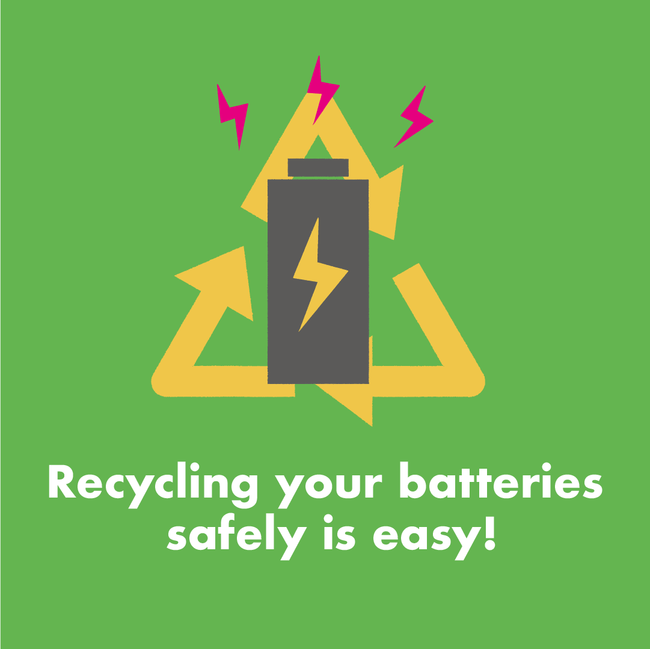
Paid Social Copy
By throwing used batteries in your rubbish bin, you’re playing with fire - literally! So when they run out, recycle them.
Organic Social Copy
If you throw your batteries in the general rubbish bin, you’re playing with fire - literally! So when they run out, store them away from other waste and recycle them at your local supermarket or recycling centre. Find out more at https://wastelesszerowastescotland.org.uk/articles/what-to-do-with-Batteries

Paid Social Copy
Take used batteries out of your devices when you can, and bring them to your local Electrical Equipment recycling point.
Organic Social Copy
Batteries found in devices like phones and laptops can be dangerous if not dealt with properly. Remove them from the device where possible and bring them to your local recycling centre or Electrical Equipment recycling point. Find out more at https://wastelesszerowastescotland.org.uk/articles/what-to-do-with-Batteries

