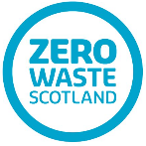
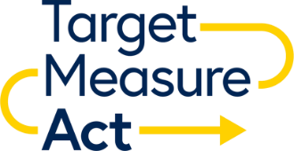

Formal letter of commitment to actively support implementation of the Scottish Government Food Waste Reduction (FWR) Target and the UK Food Waste Reduction Roadmap

To realise the objectives of both the Scottish Government FWR Target and the FWR Roadmap, Zero Waste Scotland needs the support of key businesses across the Food and Drink Sector.

The success of this will be evidenced by these key businesses embedding the principles of ‘Target, Measure, Act’ within their individual organisations.

We are asking Trade Bodies, and other enabling organisations, to commit to the following to help businesses achieve this objective, to officially sign up as a supporter of Target, Measure, Act - and be named as such on the Zero Waste Scotland and WRAP websites:

- Actively use your communication channels to promote Target, Measure Act and the Scottish Government’s Food Waste Reduction Action Plan to clients, partners (e.g. signpost to the WRAP FWR Roadmap webpage, signpost to Scottish Government’s Food Waste Reduction Action Plan, include in newsletters etc.)
- Review, discuss and agree opportunities for Zero Waste Scotland to promote Target, Measure Act at appropriate events, working groups and workshops (e.g. face2face and via webinars etc.)
- Upon request, and using your networks, to support Zero Waste Scotland to identify, and make contact with, the ‘responsible person’ in targeted businesses
- Support Zero Waste Scotland to track progress on implementation through the sharing of food waste data, surveys and insights
- Share your sector knowledge and expertise to help develop supporting FWR resources as required (e.g. participate in Zero Waste Scotland’s food waste working groups, input into the development of further guidance, tools and case studies etc.)

Name of Organisation*
Date of Commitment
Name of primary contact
Email address
Telephone number
Web (URL) address
*Please complete the name of organisation field above as you wish it to appear on the published supporters list.

If you would like to be added to Zero Waste Scotland’s food waste reduction communications, please tick here o

Signed :……………………………………………………………………………………………………
Position :…………………………………………………………………………………………………

Please return this document to email: food.drink@zerowastescotland.org.uk

Personal information will not be shared out with Zero Waste Scotland - more information on how we use your personal data can be found here. Aggregated (anonymised) food waste data will be shared with WRAP as part of the UK Food Waste Reduction Action Plan

