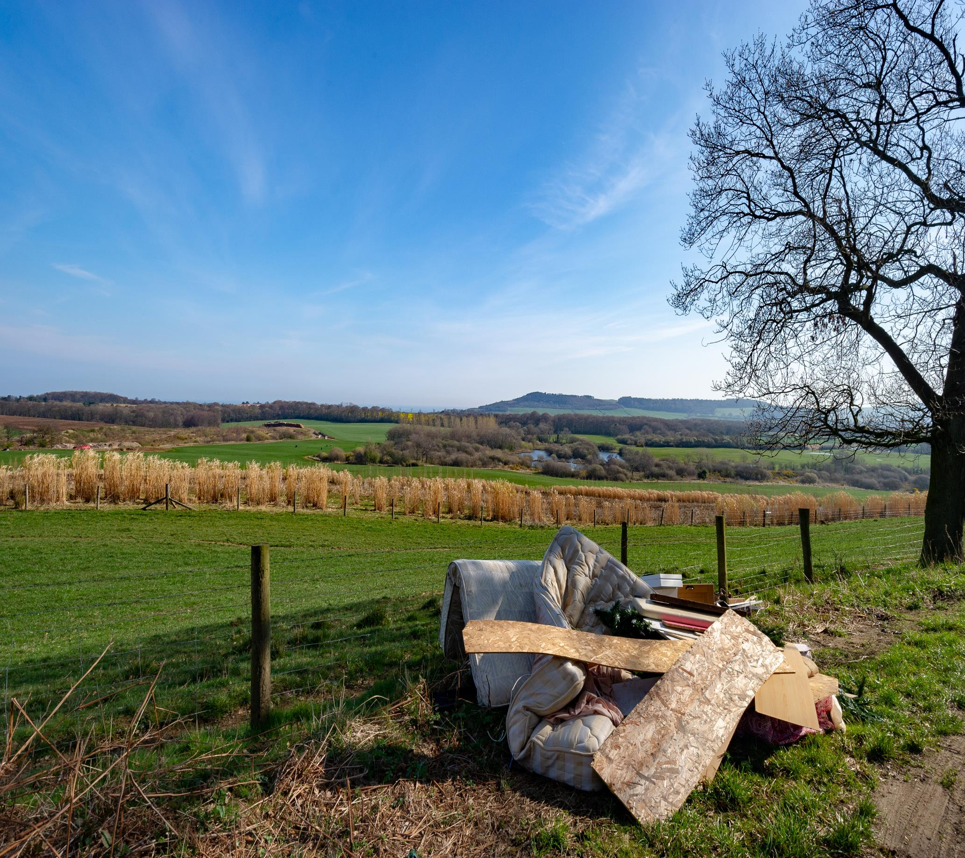

**National Litter and Flytipping Strategy Private Landowners Grant Fund**

**Zero Waste Scotland and SEPA**

**Application Form**

**October 2023**

**IMPORTANT NOTES**

**Please ensure that you read the Guidance Document in full prior to completing this application form. Please use the Guidance Document alongside this Application form to ensure that the required information is being provided correctly.**

Please complete all sections of this form electronically, altering the size of the boxes and the position of the page breaks as necessary, whilst taking account of any word / character number limits.  Incomplete applications will not be assessed.  Should you need to continue any section on additional sheets, please indicate the relevant section reference on each sheet. Appendices to support your application should be attached as required and referenced within the main body of the application form.

**SUBMISSION INSTRUCTIONS**

Please email one electronic copy of your application together with all supporting evidence to [**FlytippingSupport@zerowastescotland.org.uk**](mailto:FlytippingSupport@zerowastescotland.org.uk)

**Contents**

1 Applicant Details 4

2 Project Details 6

3 Project Costs 7

4 Project Implementation 8

5 Supplementary Information 9

6 Confidentiality and Declaration 10

# Applicant Details

|  |
| --- |
| 1.1 Name and Address of Landowner |
|  |
| **1.1.1 – Please provide confirmation and evidence that the Landowner is based in the UK** |
|  |
| 1.1.2 Is your organisation VAT registered? If so, provide your VAT registration number. |
|  |

|  |  |
| --- | --- |
| 1.2 Please provide details of the site that you require funding for: | |
| Location of Project (eg Grid Reference and photographs) | Evidence of Ownership (eg copy of title deeds) |
|  |  |

|  |  |
| --- | --- |
| 1.3 Contact Details | |
| Name and address: |  |
| Email address: |  |
| Phone number: |  |

|  |
| --- |
| 1.4 Fair Work First (only applicable to employers) |
| Is your organisation currently aligned with the Fair Work First policy? If not, is there a commitment to align with Fair Work First in the future? Please see Guidance Note for further details.  Please explain your position in relation to Fair Work First in the box below or indicate that you do not employ any staff. |
|  |

# Project Details

|  |
| --- |
| 2.1 Project Summary – please provide a summary of the proposed project (max 1000 words) |
|  |

|  |
| --- |
| 2.2 Please details what impact the proposed activity will have in terms of flytipping, engaging the community and creating economic benefit |
|  |

|  |
| --- |
| 2.3 Please provide evidence to show previous flytipping instances at the project’s location.  For example:   * Time and date stamped photos * Reports to Local Authority |
|  |

# Project Costs

|  |  |  |  |  |  |  |
| --- | --- | --- | --- | --- | --- | --- |
| 3.1 Project Costs – please provide an itemised breakdown of the costs for which you are seeking funding. | | | | | | |
| Month of Expenditure | Brief Description | Net cost  (excl. VAT)  (£) | Total Cost (incl. VAT) (£) | Funding Requested (£) | Co-funding  (£) | Quote received? Please attach as appendix. |
|  |  |  |  |  |  |  |
|  |  |  |  |  |  |  |
|  |  |  |  |  |  |  |
| **Total Cost** | | **£** | **£** | **£** | **£** |  |

|  |
| --- |
| 3.2 Please provide evidence to show that on-going costs associated with the project will be covered. |
|  |

|  |
| --- |
| 3.3 If the grant request is less than 100% of the total project costs, please provide evidence of your ability to fund the balance. |
|  |

# Project Implementation

|  |  |  |  |  |  |
| --- | --- | --- | --- | --- | --- |
| 4.1 Project Timeline – please adapt the table below to detail the timeline of the project. | | | | | |
| Activity | Sub-activity | December | January | February | March |
| *e.g CCTV* | *e.g Installation of cameras* |  |  | *x* |  |
|  |  |  |  |  |  |
|  |  |  |  |  |  |
|  |  |  |  |  |  |
|  |  |  |  |  |  |
|  |  |  |  |  |  |
| Please confirm that all spend will be within FY23/24 | | | | | |
|  | | | | | |

|  |
| --- |
| 4.2 If required, please provide detail that approvals and consents have been granted (ie. Planning permission). |
|  |

|  |
| --- |
| 4.3 Please detail how the project will continue to prevent flytipping and how the impact of the project will be monitored. |
|  |

# Supplementary Information

|  |
| --- |
| 5.1 **If you have any other relevant information you would like to add to support your proposal, please include it here or as an attachment and list your appendices below.** |
|  |

# Confidentiality and Declaration

|  |
| --- |
| **Conﬁdentiality and Privacy** |
| Please note that Zero Waste Scotland is required to share your application with SEPA and other law enforcement agencies to enable the application to be assessed and to facilitate management of the fund.  **By completing this form, you permit the sharing of information for this purpose.**    Information that you provide to Zero Waste Scotland will be treated in the strictest of conﬁdence and in line with all information regulations, except when we are required to disclose data by law or applicable regulatory requirement, including any disclosure required under the Freedom of Information (Scotland) Act 2002 and/or any code or applicable data agreement relating to disclosure and access to information held by public bodies.    Zero Waste Scotland is committed to protecting and respecting your privacy. Our privacy policy <http://www.zerowastescotland.org.uk/content/privacy-policy> explains how we collect and process your personal information for funding and support applications. If you have any requests concerning your personal information or any queries with regard to our processing practices, please contact us at [data@zerowastescotland.org.uk](mailto:data@zerowastescotland.org.uk) .  All information provided to ZWS will held for the statutory period of 6 years. You may unsubscribe from and request to no longer receive product and service information from us at any time by emailing [communications@zerowastescotland.org.uk](mailto:communications@zerowastescotland.org.uk) . |

|  |
| --- |
| **Declaration** |
| I declare that:    The information given on this form and in any other documentation is accurate to the best of my knowledge.  I understand that, where any materially misleading statements (whether deliberate or accidental) are given at any stage during the application process, or where any material information is knowingly withheld, this could (at the discretion of Zero Waste Scotland) render my application invalid and any funds received by us will be liable for repayment.    I confirm that we will take all reasonable precautions to ensure that any funding received will not be misused or misappropriated in any way.  In the event of a fraud, I understand that Zero Waste Scotland may take legal action to recover any misappropriated funds.  I confirm that the project would not proceed in the absence of this grant.    I agree that the information supplied on this form, including individual contact information, will be used to chart the success of the project and for monitoring purposes. |

|  |  |
| --- | --- |
| **To be signed by Landowner** | |
| Signed: |  |
| Print Name: |  |
| Contact email address and phone number: |  |
| Date: |  |