LA Logo here

✍ Contact details here
Contact details here
Details here
Details here
Details here

Dear householder,

Your recycling and waste services are changing

We are making improvements to your recycling and waste services so we can deliver these collections more efficiently, this means we can make savings which will help maintain other local services.

What is happening?

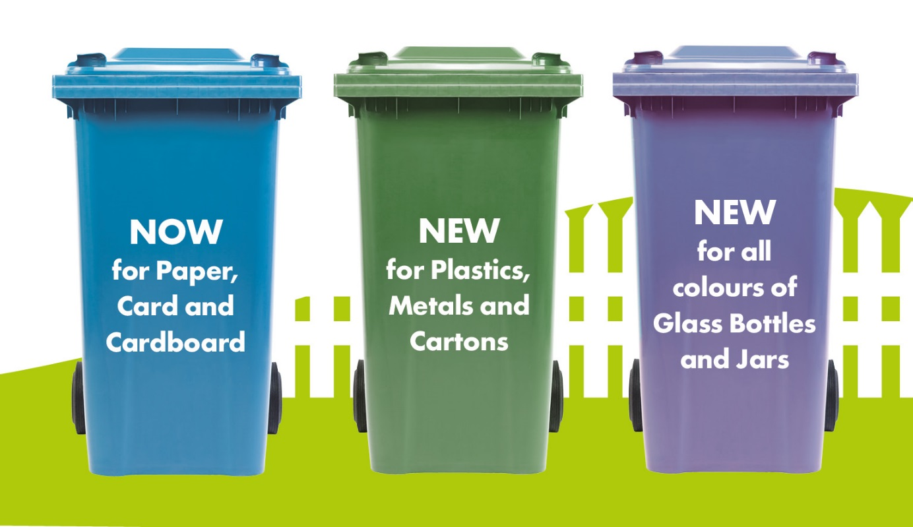
By making these changes we are also helping to move Scotland closer to more consistent recycling
across the country, meaning no matter where you live recycling services will be easier to understand
and use.

When is this happening?
✍ (Give details on the timescale of when you are making the changes. Be careful about using
specific dates if there are likely still to be changes to be made to the delivery schedule etc)

What’s next?
We will send you further information shortly including a full guide to your new service so you can
see how to use your recycling bins correctly to recycle over 70% of things in your household.
✍ (Add in any additional information you need to about new containers or switching container
purpose here/last collections)
Key changes at a glance

Further information
If you have any questions about these changes or need more information please visit:
✍ www.councilwebsite.com or call xxxxxxx and we will be happy to help. ✍ (Add details of any
local events or roadshows you might be doing to support the changes)

Yours faithfully,
✍ Signature here
✍ (Name of Council contact)
✍ (Title)

